**Example Question Types for Importing**

By Coursera

## **INTRODUCTION**

Use this document to learn more about the formats supported for uploading documents into Coursera to automatically create auto-graded questions.

Throughout this document, you can read comments in the margin from Coursera to learn quick tips:

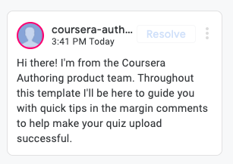

Documents formatted like the examples below can be imported into Coursera to automatically create assessments and question banks. We support most [auto-graded question types](https://partner.coursera.help/hc/articles/115000173563-Supported-Question-Types-Quizzes) and [rich text formatting](https://partner.coursera.help/hc/articles/360039540792-Using-the-Text-Editor-in-the-Course-Authoring-Tool) available on the Coursera platform. [Learn more about how to upload and download questions](https://partner.coursera.help/hc/articles/360002997431).

You can find an [**auto-graded questions template ready to be used here**](https://www.coursera.org/template-documents/coursera-quiz-questions-import-template), or create your own template using these formatting guidelines.

## Table of Contents

GETTING STARTED

Question Formatting

Question Properties

Question Banks - Special Formatting

The Importance of Feedback

Default feedback & Option-specific feedback

QUESTION TYPE EXAMPLES

Single Correct Answer

Multiple Correct Answers

Text Match

Regular Expression

Math Expression

Numeric

Reflective Single Choice

Reflective Multiple Choice

Reflective Text Answer

OTHER FORMATTING CONSIDERATIONS

Rich Text Formatting

MathJax

Embedded Images

Using Headers and Indentation

Multi-paragraph Question

## GETTING STARTED

### Question Formatting

Here is an annotated example showing how questions should be formatted:

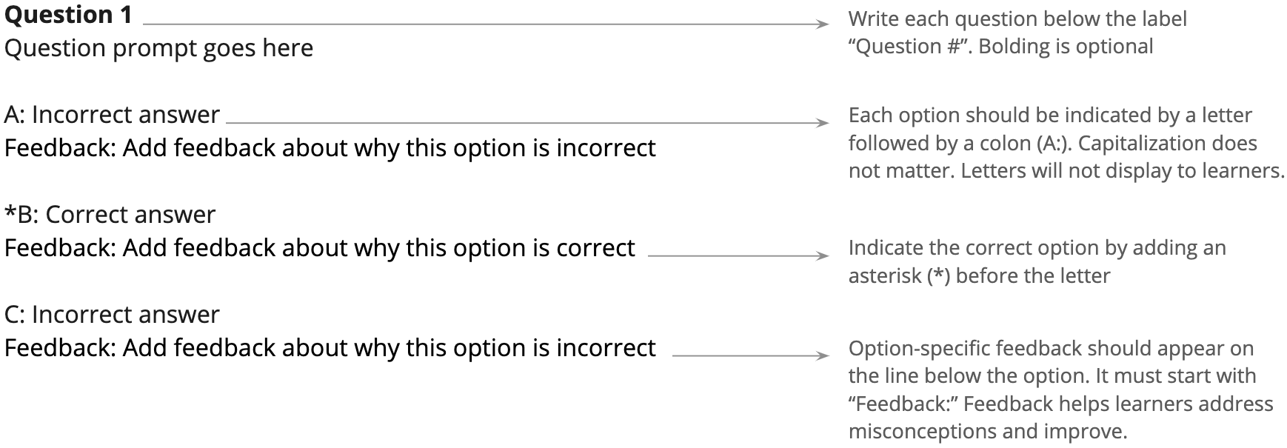

Many question types can be imported. See **Question Type Examples** for more details.

### Question Properties

Coursera assumes some default properties for each question, as detailed below.

If you would like to specify a property that is different from the default, you can include it by adding a dash "-" after the question title and writing down the properties. To add multiple properties, separate them with commas.

For example: **Question 1 - variation 1, checkbox, shuffle, partial credit**

Properties you can specify include: *(Note: These are all optional)*

1. **Question type:**

Default: “multiple choice”

*Depending on the number of options that are indicated as correct with an asterisk (*), questions will be interpreted as “single correct answer” or “multiple correct answers” aka “checkbox”.*  
  
Other options: “text match”, “regex” or “regular expression”, “math expression”, “numeric”, “reflective multiple choice”, “reflective single choice”, “reflective text answer”

1. **Variations:**

Default: not a variation

Other options: “variation 1”, “variation 2”, “variation 3”, etc.

1. **Shuffle:**

Default: “no shuffle”

Other option: “shuffle”

1. **Partial credit:** *(Note: This is only relevant for the “multiple correct answers” question type)*

Default: “no partial credit”

Other option: “partial credit”

### Question Banks: Special Formatting

When using question banks, you can enable more advanced features with special formatting. These include assigning difficulty levels and question categories to questions.

Later, in the assessment, you can target specific difficulty levels and/or question categories using question blocks.

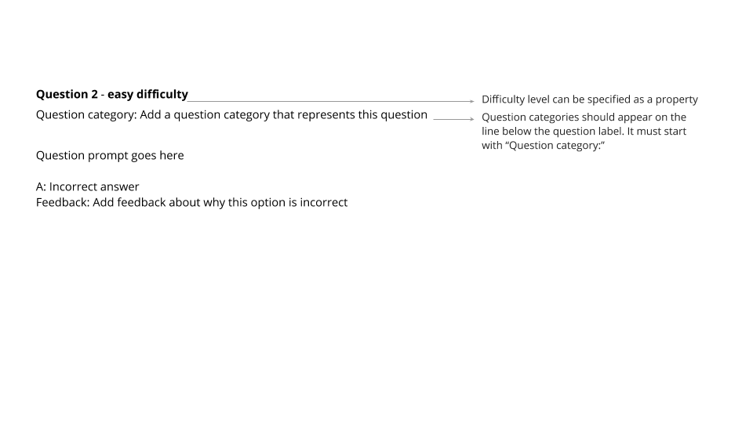

All questions and their formats shown in this document can be imported into question banks. If you import a file with special formatting directly into an assessment rather than into a question bank, the difficulty level and question category will be ignored.

[**Learn more about question banks here.**](https://partner.coursera.help/hc/articles/360052649072)

Copy the following example to get started with special formatting within question banks.

**Question 2** - **easy difficulty**

Question category: Add a question category that represents this question

Question prompt goes here

A: Incorrect answer

Feedback: Add feedback about why this option is incorrect

*B: Correct answer

Feedback: Add feedback about why this option is correct

C: Incorrect answer

Feedback: Add feedback about why this option is incorrect

### The Importance of Feedback

Feedback is important for both practice and graded assessments. Immediate feedback is a vital component of the mastery-based learning experience provided through the Coursera platform. [Research](https://www.ideals.illinois.edu/bitstream/handle/2142/97264/FEIN-DISSERTATION-2017.pdf?sequence=1&isAllowed=y) shows that immediate and actionable feedback on assessments can support better learning outcomes. Coursera’s learning platform makes it possible to provide this immediate feedback to learners. [Learn more about optimizing feedback for quizzes](https://partner.coursera.help/hc/articles/115001468086-Optimize-Quizzes).

The type of feedback you provide will depend on whether the quiz is practice or graded.

**Practice:**

For practice (formative) quizzes, include an explanation about **why the answer is correct or incorrect**. This helps learners address misconceptions and prevents them from repeating the same mistakes in the future. Practice quizzes are used to monitor student learning and provide ongoing feedback. They also provide low-stakes opportunities for learners to deepen their understanding of new concepts and to prepare for summative assessments. For example:

**Question 1 - single correct answer, shuffle**

Which sentence is a compound sentence?

A: Jamie bought a new computer and put it in her bedroom

Feedback: This is a simple sentence. There is no subject after “and”

*B: Ross lives in New Jersey, and he works in New York City

Feedback: This is a compound sentence because it has two sentences joined by an “and”.

**Graded:**

For graded (summative) quizzes, **refer learners to relevant review materials without revealing the answer**. Your feedback about incorrect options should not give away the answer since this is summative material. Your feedback about correct options should reinforce why that option is correct. Graded quizzes evaluate student learning at the end of an instructional item and formally evaluate learners’ levels of mastery. For example:

**Question 1 - single correct answer, shuffle**

In a data science course, one of your learners failed the first graded assessment. She truly wants to complete the course and become a skilled data scientist. What should she do, according to the concept of mastery learning?

A: Try to find an easier topic in a different course, and leave the data science aspirations aside for now.

Feedback: This will not support the learner in her journey to master the difficult topic she chose. Try going back to the video about mastery learning to review.

*B: Review the materials in the first module, and re-attempt the assessment that she failed.

Feedback: Exactly. According to mastery learning, a growth mindset is crucial in learning. Re-attempting assessments and learning from failures is part of this process.

Feedback can take different forms depending on the question type:

|  |  |  |
| --- | --- | --- |
| **Question Type** | **Option-specific Feedback supported?** | **Default Feedback supported?** |
| Multiple Choice | **YES** | **NO** |
| Text Match | **YES** | **YES** |
| Numeric | **YES** | **YES** |
| Math Expression | **YES** | **YES** |
| Regular Expression | **YES** | **YES** |
| Reflective Multiple Choice | **YES** | **NO** |
| Reflective Single Choice | **YES** | **NO** |
| Reflective Text Answer | **NO** | **YES** |

## QUESTION TYPE EXAMPLES

### Single Correct Answer

**Question 1** **- multiple choice, shuffle**

Question prompt goes here

A: Incorrect answer

Feedback: Add feedback about why this option is incorrect

*B: Correct answer

Feedback: Add feedback about why this option is correct

C: Incorrect answer 2

Feedback: Add feedback about why this option is incorrect

### Multiple Correct Answers

**Question 1** **-** **checkbox, shuffle, partial credit**

Question prompt goes here

A: Incorrect answer

Feedback: Add feedback about why this option is incorrect

*B: Correct answer

Feedback: Add feedback about why this option is correct

*C: Correct answer 2

Feedback: Add feedback about why this option is correct

D: Incorrect answer 2

Feedback: Add feedback about why this option is incorrect

### 

### Text Match

**Question 1 - text match**

What is the tallest mountain on Earth?

*A: Mount Everest

Feedback: Yes, Mount Everest is the tallest mountain on Earth. It is 8,848 metres (or 29,029 feet) high.

B: Mount Kilimanjaro

Feedback: Not quite right. Although Mount Kilimanjaro is a commonly-known tall mountain, it is not the tallest on Earth.

Default Feedback: Review Week 2 to learn more.

### Regular Expression

**Question 1 - regular expression**

What is a group of cats called?

*A: [cC]lowder|[gG]laring

Feedback: That’s correct! A group of cats is called a clowder or a glaring.

Default Feedback: Review Week 3 to learn more.

### Math Expression

**Question 1** **- math expression**

A spherical water droplet has radius $$r$$. What is its surface area? Enter ‘pi’ as $$pi$$.

*A: 4 * pi * r^2

Feedback: That’s correct!

B: 4/3 * pi * r^3

Feedback: No - $$4/3 * pi * r^2$$ is the volume of a sphere.

Default Feedback: Review Week 2 for an explanation of spherical geometry.

### Numeric

**Question 1 - numeric**

How many planets are in our solar system?

A: [-1, 8)

Feedback: You’re forgetting some planets, that’s not enough.

*B: 8

Feedback: That's correct as of 2006, when Pluto was officially relegated to the status of dwarf planet.

C: 9

Feedback: This was correct pre-2006, and many today still consider Pluto a planet in popular culture.

Default Feedback: Review Lecture 7 to learn more.

### Reflective Single Choice

**Question 1 - reflective single choice**

Have you enjoyed this course so far?

A: Yes, a lot!

Feedback: That’s great to hear :)

B: No, not yet.

Feedback: Sorry to hear that. Please reach out to the course staff to share your feedback about how we could improve this course.

Default Feedback: You did not choose an option.

### Reflective Multiple Choice

**Question 1 - reflective multiple choice**

What do you think about this course so far?

A: It teaches many good concepts.

Feedback: That’s great to hear :)

B: It lacks certain topics that would be beneficial.

Feedback: We're working on it! Please reach out to the course staff and share your ideas.

C: The assignments are too easy.

Feedback: Challenge accepted!

### Reflective Text Answer

**Question 1 - reflective text answer**

Why did you enroll in this course? What goals do you have that this course can help you with?

Default Feedback: Thank you for reflecting on your goals for taking this course!

## OTHER FORMATTING CONSIDERATIONS

### Rich Text Formatting

**Question 1 - multiple choice**

There are multiple **modes of transportation**. Refer to [this list](https://en.wikipedia.org/wiki/Mode_of_transport) of vehicles if needed. Which of these modes of transportation have more than 2 wheels? *Check all that apply.*

A: Unicycle

Feedback: A unicycle only has 1 wheel. Review [Video Lecture 2.3](http://example.com).

B: Bicycle

Feedback: A bicycle has exactly 2 wheels. Review [Video Lecture 2.3](http://example.com).

*C: Tricycle

Feedback: A tricycle has 3 wheels. Review [Video Lecture 2.3](http://example.com).

*D: Car

Feedback: A car has 4 wheels. Review [Video Lecture 2.3](http://example.com).

### MathJax

**Question 1 - multiple choice**

Calculate

$$\begin{pmatrix}3&2\\0&2\\ \end{pmatrix} + \begin{pmatrix}4&12\\1&2\\ \end{pmatrix}$$

A. $$\begin{pmatrix}12&24\\0&2\\ \end{pmatrix}$$

Feedback: Please review Addition

*B. $$\begin{pmatrix}7&14\\1&4\\ \end{pmatrix}$$

Feedback: You got it!

C. $$\begin{pmatrix}7&12\\0&4\\ \end{pmatrix}$$

Feedback: Please review Addition

### Embedded Images

### **Question 1**

Say you are building a smart speaker, and want to accumulate data for your product through having many users. Which of these represents the “Virtuous circle of AI” for this product?

*A: 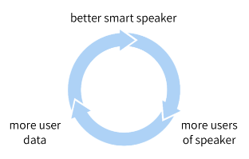

Feedback: Better products acquire more users and get to acquire more data and produce an even better product.

B: 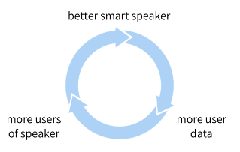

Feedback: Try again! [Review AI Transformation Playbook (Part 2)](http://www.example.com)

C: 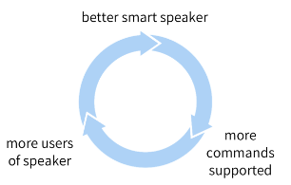

Feedback: Try again! [Review AI Transformation Playbook (Part 2)](http://www.example.com)

D: 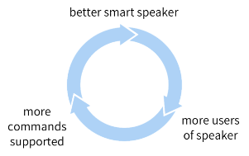

Feedback: Try again! [Review AI Transformation Playbook (Part 2)](http://www.example.com)

### Using Headers and Colors

### **Question 1**

Question prompt goes here

A: An answer

Feedback: Feedback for the incorrect answer

*B: Another answer

Feedback: Feedback for the correct answer

### Multi-paragraph Question Prompt, Using Headers and Colors

### **Question 1 - single correct choice**

**Flipping the classroom**

A lecturer wants to investigate the effectiveness of an instructional method called 'Flipping the Classroom' (FtC). The teacher investigates this method with pre master students and regular bachelor students studying Communication Science, who are taking the course Statistics-II together. Under the guise of extra support, four days before each lecture, the pre master students get access to the video recordings of last year’s lecture. They are asked to study these recordings carefully.

The effectiveness of the ‘standard’ versus the FtC instructional method will be investigated by comparing exam scores (study performance, score range: 1 – 10, interval variable) of the two groups. During the exam a questionnaire is used to measure self-confidence and study motivation (both interval variables with a score range of 10 – 50) and age, gender and the math score obtained in secondary school (on final exams).

*Disclaimer: this research is completely made up!*

This research is…..

#### A: Correlational Feedback: No, the investigated relation is causal and the independent variable was manipulated.

#### B: Experimental Feedback: No, the conditions consist of pre-existing groups, there was no random assignment.

#### *C: Quasi-experimental Feedback: Good work! Quasi-experimental research involves the manipulation of an independent variable without the random assignment of participants to conditions or order of conditions.